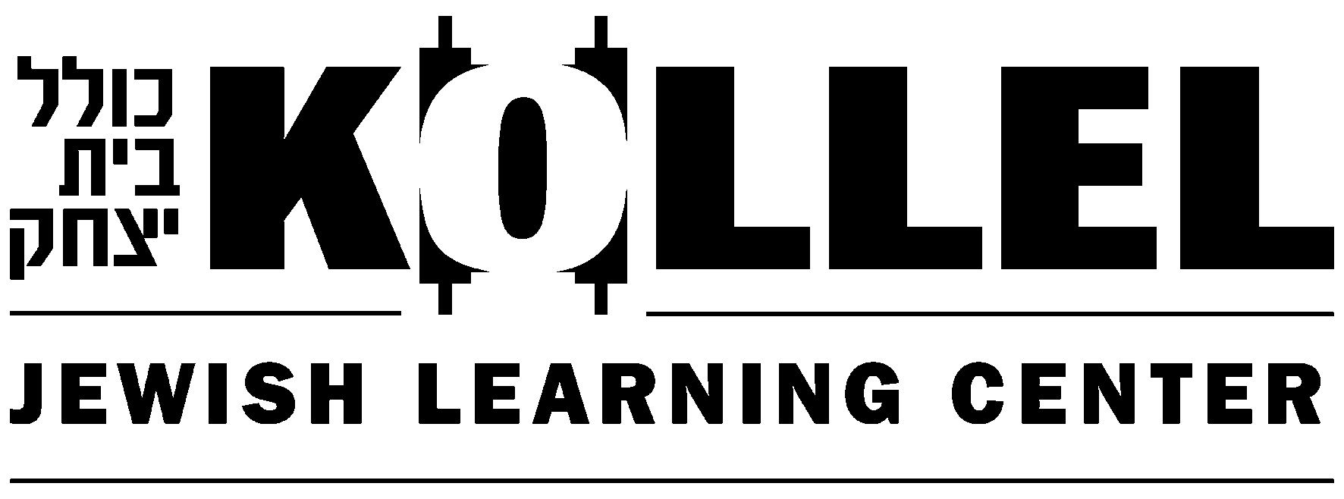

The Kollel Jewish Learning Center offers Torah classes for every interest!

- Yom Tov Themed Lectures
- Legal Holiday Learning
- One-On-One Learning
- Text-Based Study Groups
- Women’s Summer Learning Program
- Kollel Konnections Men’s Program
- Open Bais Medrash and Library Stocked with Hebrew and English Seforim
- Mishnah On Campus
- Plus Much, Much More!

Let us match you up with one of our scholars for one-on-one learning – at no charge!

Create Your Own Class! We will arrange a teacher for any group of six or more people in the Torah topic of their choice.

For more information or to add yourself to our email list contact:
Rabbi Avrohom Rodkin, Director of Education
412-420-0220 ext. 208 or arodkin@kollelpgh.org

Kollel Jewish Learning Center 5808 Beacon St. Pittsburgh PA 15217

